 Assignment Cover Sheet

Student Information (For group assignment, please state names of all members) |  | Grade/Marks
Name | ID
Adrienne Kayana Wistara Lie | E2400071
Bagoes Chinmayananda Ariel Oka | E2400074
Ivan Maulana | E2400084

Module/Subject Information |  | Office Acknowledgement
Module/Subject Code | BIT216
Module/Subject Name | Software Engineering Principles
Lecturer/Tutor/Facilitator | Seetha Letchumi
Due Date | Saturday, 21st March 2026
Assignment Title/Topic | Assignment 1 – Task 1
Intake (where applicable)
Word Count | 2404 | Date/Time

Declaration
- I/We have read and understood the Programme Handbook that explains on plagiarism, and I/we testify that, unless otherwise acknowledged, the work submitted herein is entirely my/our own.
- I/We declare that no part of this assignment has been written for me/us by any other person(s) except where such collaboration has been authorized by the lecturer concerned.
- I/We authorize the University to test any work submitted by me/us, using text comparison software, for instances of plagiarism. I/We understand this will involve the University or its contractors copying my/our work and storing it on a database to be used in future to test work submitted by others.
Note: 1) The attachment of this statement on any electronically submitted assignments will be deemed to have the same authority as a signed statement.
2) The Group Leader signs the declaration on behalf of all members.

  Signature: | Date: Saturday, 21st March 2026
E-mail: 230030369@stikom-bali.ac.id

Feedback/Comments*
Main Strengths
Main Weaknesses
Suggestions for improvement

 | Student acknowledge feedback/comments
Grader’s signature |   Student’s signature:
Date: | Date: Saturday, 21st March 2026
Note:
- A soft and hard copy of the assignment shall be submitted.
- The signed copy of the assignment cover sheet shall be retained by the marker.
- If the Turnitin report is required, students have to submit it with the assignment. However, departments may allow students up to THREE (3) working days after submission of the assignment to submit the Turnitin report. The assignment shall only be marked upon the submission of the Turnitin report.

*Use additional sheets if required.


Save Plate - Smart Food Waste Reduction App

BIT216 Software Engineering Principles

Team Leader:
E2400084 Ivan Maulana
Team Member:
E2400074 Bagoes Chinmayananda Ariel Oka
E2400071 Adrienne Kayana Wistara Lie

Contact:
ivanmaulana22sch@gmail.com
230030369@stikom-bali.ac.id
adrikayanacollege@gmail.com

BACHELOR OF INFORMATION TECHNOLOGY (HONS)
HELP UNIVERSITY

MARCH 2026

Table of Contents
1 Overview 1
2 Project Aims 2
3 Project Objectives 2
4 Project Scope 3
4.1 Project Deliverables 3
4.2 Technical and Implementation Scope 4
4.3 Boundaries and Non-Deliverables 4
5 Project Schedule 5
6 Technical 8
6.1 Development Platform 8
6.2 Demonstration Platform 11
7 Risk management plan 12

Overview
Food waste is one of the biggest global challenges that can happen due to poor planning, lack of knowledge on how to manage food, and impulsive buying. Food waste is not only just an environmental issue, but also economic and social, meaning the number of leftover materials we are unaware of, such as wasting money as we literally throw food away. Another example that we also get in social aspect is by having a habit of wasting food, we are also weakening the act of combat hunger. Because there are many people worldwide that lack sufficient nutrition, making it social imbalance. Because of that, we decided to create an app that can track your food on-the-go, helping the user to help reduce food waste worldwide.
The app can be used for household users, including individuals and families who manage food with the goals of:
- Reducing amounts of food wasted.
- Donate surplus food items to others in their community.
- Improve their planning habits based on their ingredients.
- Helping them to get educated and get track on food waste program.
The project will be deliver a new mobile-based application called SavePlate. A new application, build from scratch that focused on the following core features:
- Intellegent Inventory Management.
- Donation Facilitation.
- Meal Planning, Education and Analytics.
As for this project development, we acknowledge that this will cost us some time to make it from scratch. During development, we targeted to heavily on resource hours, rather than actual funds to support our project. With that said, we are prioritizing free utility that has been provided to support this project.
The project timeline will follow the schedule that has been given in assignment folder. These are the following plan timelines:
- By the end of week 2, April 4th, we have finalized the planning structure and design.
- Implementation and Testing will occur throughout the subsequent weeks leading to the final project presentation in Assignment 2.
- Total Duration of our project is approximately 8 to 10 weeks of development.

Project Aims
As our aim to reduce the food wasting, these are the following aim that we propose in this project
- Minimize Household Food Waste.
- Foster Community-Based Food Sharing.
- Promote Sustainable Consumption Habit.
- Enhance Resource Efficiency with Addition of Education.

Project Objectives
The main objective of the SavePlate project is to develop a system capable of helping to address the problem of household due to food waste by achieving the following strategic and goals:
- Inventory Management
Create a digital inventory system that allows user to record household food items and categorized based on food group to ensure the accurate information within the system.
- Waste Prevention
Implementing automated alert notification system to notifies user two days before items expiry date to ensure user consume the food before it spoils
- Sharing with Community
Provide a real time location of nearby food banks or community center to facilitate donation of surplus household food supplies
- Meal Planning
Provide a meal suggestion based on the food items that are available on inventory system and recommend an item that are close to their expiry dates to be use as the meal
- Secured User Data
Build a secure account and data management system to ensures all user details and personal data remain private and protected from external intervention

Project Scope
The SavePlate project delivers a web app, designed to help minimize food waste for households. The scope of the project defined by the following functional requirements and boundaries.

Project Deliverables
The system must provide a comprehensive design and solid foundation for the web app with the following use case:
- Account and Security Requirements
The system must facilitate a formal registration process, with protection security protocol such as Two-Factor Authentication (2FA) via email verification to ensure account integrity and data privacy. Users must maintain the ability to modify privacy settings and food listing visibility through a secure dashboard.
- Digital Inventory and Lifecycle Management
Users must be able to perform granular logging of household food items, including name, expiry date, quantity, and category. The interface must support state transition, allowing items to be marked as “used”, “Donated”, or “Reserved” for meal planning.
- Community Surplus Discovery
Web application shall host a marketplace for surplus food, allowing users to browse listing filtered by either location or food type. Detailed pickup arrangements and contact method must be visible to facilitate successful redistribution.
- Quantifiable Impact Analytics
A data-driven reporting module is required to visualized user contributions to waste reduction. This includes dynamic charts reflecting total food saved and donation frequency, filtered by specific time range to maintain user engagement.
- Automated Notification Engine
The system is responsible for generating timely alerts for critical events, specifically expiry warnings 48 hours in advance, donation claim confirmation, and automated reminders for scheduled meal plans.
- Inventory-Driven Meal Optimization
A calendar-based planning tool will allow users to organize meals for the week. The system’s logic must prioritize expiring ingredients when suggesting recipes to maximize ingredient utilization and to minimize spoilage or wasting food.

Technical and Implementation Scope
The development of SavePlate will be strictly governed by the following technical specifications:
- Frontend Architecture
A responsive, single-page application developed by using Vue.js framework to ensure a modern, efficient user experience.
- Data Management
Utilizing MongoDB as the NoSQL database for flexible storage of unstructured food item data and user records.
- Collaboration and Versioning
All source code and documentation must be maintained in a GitHub repository, with task tracking strictly managed through GanttProject and Microsoft Excel.

Boundaries and Non-Deliverables
To ensure the project remains within the estimated development lifecycle, the following are strictly excluded:
- Native Mobile Support
This project will be focused on a web-based application, meaning that native Android or iOS development is not included.
- Offline Operation
The system will not function without a stable internet connection, as real-time synchronization with the database is required.
- Payment and Logistics
The platform does not handle financial transactions, including physical transportation for food donations.

Project Schedule
Work Breakdown Structure
File Link: https://drive.google.com/drive/folders/1FcfNtGuToGLkUbd5W3yOA0w4e-Y7d4_r?usp=sharing

Gantt Chart
File Link: https://drive.google.com/drive/folders/1FcfNtGuToGLkUbd5W3yOA0w4e-Y7d4_r?usp=sharing
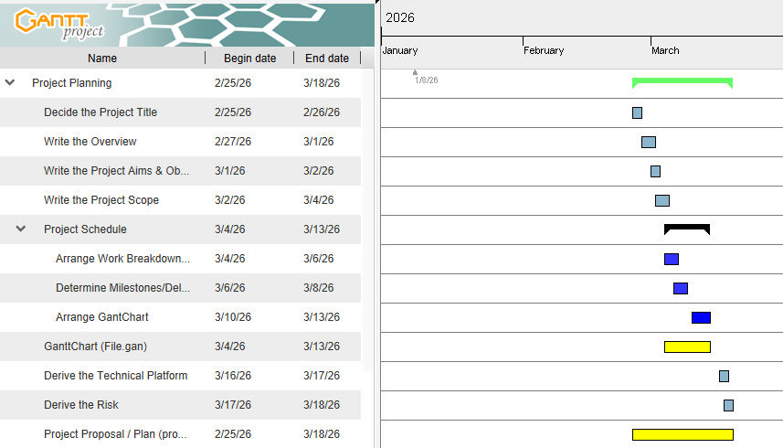
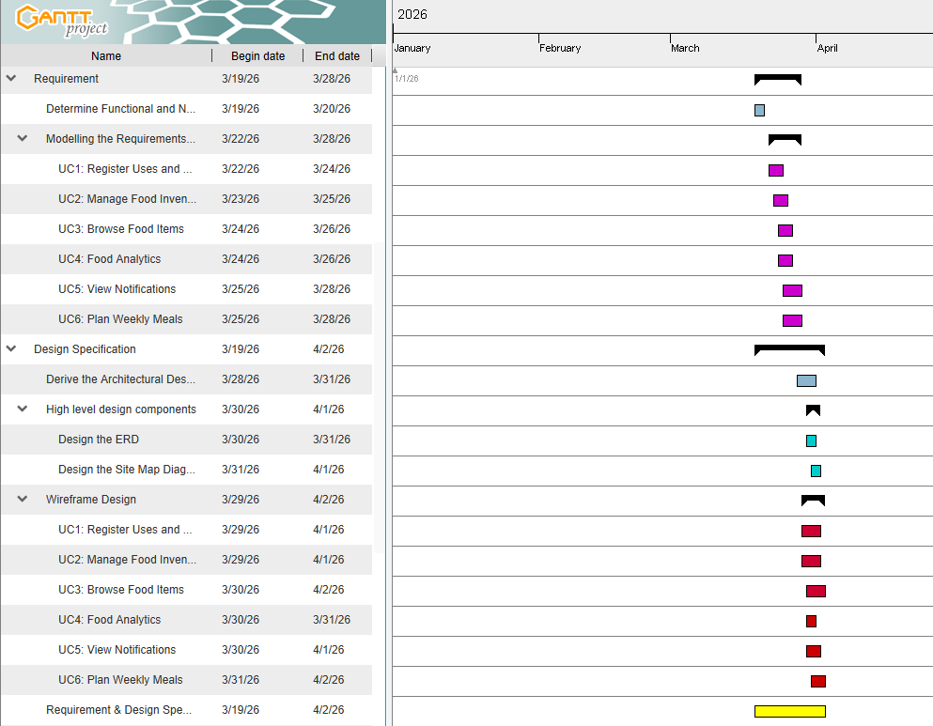
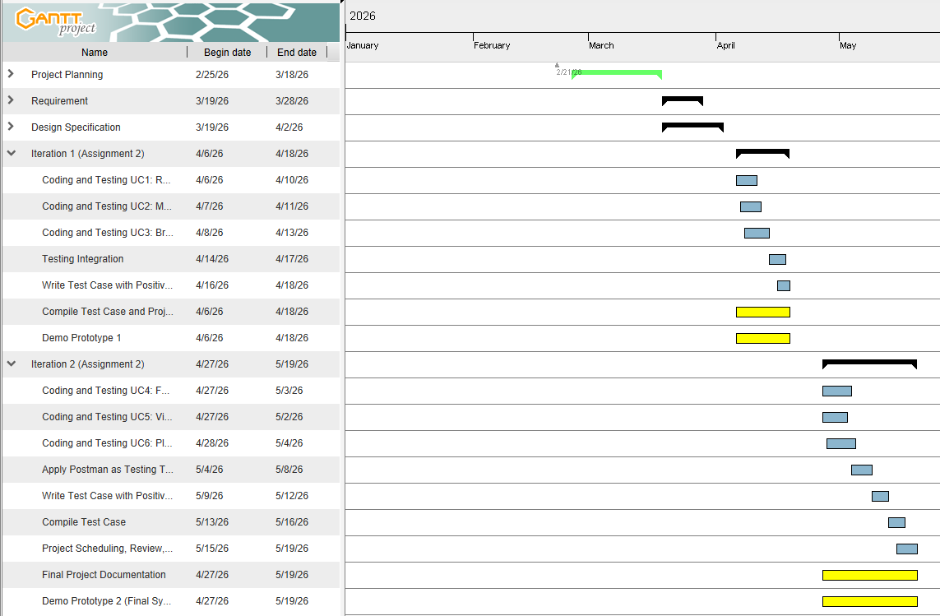

Technical

Development Platform
Criteria |  | Tools/Hardware | Version | Description
 | Documentation | Microsoft Word | 2602 | Software used for documentation with form of text and images, full explanation about the project documentation, testing, and report.
 |  | Microsoft Excel | 2602 | Software used for more advanced details, including data input, graph, and numbering. Based case for analyzing project, breaking down work schedule, and as tracker for progress that currently work project.
 |  | Microsoft Powerpoint | 2601 | Software used for proposed project in visual documentation and explain key points about the project itself. Based case for presentation the ongoing project and meeting presentation.
Modeling
Requirement |  | Excalidraw | Web-based | Free, open source, virtual whiteboard that can be used for creating diagrams, wireframes, and sketches. Based case for collaborating to discuss current project plan, sketching system and operation plan.
 |  | Canva | Web-based | A platform used for prototyping. Allows team to design wireframe with high quality assets to ensure consistent visual identity
Design |  | Figma | Web-based | Cloud-based tools to create prototype a design for friendly UI and UX for both mobile apps and website.
 |  | Canva | Web-based | Graphic design, built web-based to create visual content such as presentation material, simple design, poster with many built-in elements used to improve visual presentation.
Project Management |  | GanttProject | 3.3 | Open-source desktop software for project scheduling and management. It allows to create Gantt charts, assign resources, and track project progress to ensure it is met with the timeline
 |  | Microsoft Excel | 2602 | Software used for more advanced details, including data input, graph, and numbering. Based case for analyzing project, breaking down work schedule, and as tracker for progress that currently work project.
 |  | Microsoft Word | 2602 | Software used for documentation with form of text and images, full explanation about the project documentation, testing, and report.
Collaboration |  | Git |  | A version control system to track every change to the source code during development phase. This allows multiple people to work together within the same source code
 |  | GitHub | Web-based | A cloud-based hosting service for repositories on Git. GitHub facilitates team collaboration by providing tools for centralized project storage, and code review
 |  | Microsoft Word | 2601 | Software used for documentation with form of text and images, full explanation about the project documentation, testing, and report
Framework
Front End |  | Vue.js | 3.5 | A progressive JavaScript framework for building UI that allows to create a reactive, single page application with a smooth experience for user
Backend |  | Express.js | 5.2.1 | A flexible Node.js web framework providing several sets of features to handle server-side logic, routing, and API request between backend and frontend
Database |  | MongoDB | 8.0 | Document oriented database, with flexible data stores make it easy to scale and integrate with JavaScript framework
 |  | MongoDB Compass | 1.48.2 | The GUI of MongoDB, used to visually show query and manage database without writing complex command line
Testing Tools |  | Postman | 12.2.3 | An API platform for testing and documenting APIs. Allows to send request to backend and ensure data is handled correctly to the front end
Hardware (Notebook Spec) |  | Ryzen 5  3.6Ghz |  | Hardware Spec :  Ryzen 5  32 GB Ram  1 TB Storage

Demonstration Platform
Criteria | Tools/Hardware | Version | Description
Browser | Microsft Edge | 146.0.3856.62 | A chromium base web browser used as the demonstration platform. By providing high performances environment to run Vue.js framework with integrated DevTools to inspect API response from backend

Risk management plan
Risk Name | Description | Probability (L/M/H) | Mitigation Strategy
User Privacy & Data Leak | Potential unauthorized access to household addresses or account credentials stored in the database. | M | Enforce Mandatory Two-Factor Authentication (2FA) and encrypt all sensitive user data at rest and in transit.
Inventory Desynchronization | Discrepancy between actual physical food stock and the app's digital record if users forget to log "used" items. | H | Implement automated "Push Notifications" and weekly email digests to remind users to audit their pantry and fridge status.
Server/Platform Downtime | Technical failure of the web hosting service preventing users from accessing their meal plans or donation listings. | L | Utilize a reliable cloud-based hosting environment (e.g., AWS or Firebase) with automated backup schedules every 24 hours.
Donation Safety Concerns | Risks associated with the quality of food items listed for donation by household users. | M | Include a mandatory "Expiry Date" field and "Storage Category" (e.g., chilled, frozen) for every donation listing to ensure transparency.
Project Schedule Slippage | Delays in developing complex features like "Food Analytics" or "Weekly Meal Planning" within the iterative cycle. | M | Strictly follow the Work Breakdown Structure (WBS) and conduct weekly team syncs to monitor progress against the Gantt Chart baseline.
Unsuccessful Donation Match | Items marked for donation expire before a nearby user claims them. | H | Enable location-based filtering so items are visible to the most relevant local users and set "Urgent" flags for items within 48 hours of expiry.

Appendix B: Marking Scheme
Student 1: | Ivan Maulana / E2400084
Student 2: | Bagoes Chinmayananda Ariel Oka / E2400074
Student 3: | Adrienne Kayana Wistara Lie / E2400071
LO | Assessment Area | Marks | Poor | Satisfactory | Good | Excellent |  | Marks
CLO2 | Appropriate level of scope coverage [17]
 | Title | 1
 | Overview | 4
 | Project Aims | 4
 | Project Objectives | 4
 | Project Scope | 4
CLO2 | Project plan [15]
 | Work breakdown | 5
 | Milestones/Deliverables | 5
 | Gantt chart - Timelines, Predecessors, Resource Usage, milestones | 5
CLO2 | Resource planning [8]
 | Development  Hardware/Software | 4
 | Demo Environment Hardware/Software | 2
CLO2 | Risk Management [4] | 2
CLO3 | Documentation[10]
 | Format Consistency | 10
 | Spelling/Grammar
 | Professionalism
 | TOTAL | 50 | SubTotal  ( /50) |  |  |  |  | 0
B. Requirements
CLO2 | Requirements definition [5]
 | Functional Requirements | 3
 | Non-functional Requirements | 2
CLO2 | Requirements specification [20] |  |  |  |  |  |  | Student 1 | Student 2 | Student 3
 | [1 + 2 + 4 + 3 = 10]  Epic + User Stories + AC+ Tasks | 10
 | [1 + 2 + 4 + 3 = 10]  Epic + User Stories + AC+ Tasks | 10
C. Design | Design [15]
CLO2 | Architectural Design | 2
 | Site Map | 2
 | Data Design [2]  Database/File Design [3] | 5
 | Wire frames [6] | 6
CLO3 | Documentation [10]
 | Format Consistency | 10
 | Spelling/Grammar
 | Professionalism
 | TOTAL | 50 |  |  |  | Sub-total  (/50 marks) |  | 0 | 0 | 0
 |  |  |  |  |  |  |  | Student 1 | Student 2 | Student 3
Violation of Academic Integrity Penalty
Late Submission | 5 marks per day ( ____ days)
 |  |  |  |  |  | TOTAL |  | 0 | 0 | 0

